February 14: Oklahoma Science Teachers Workshop

TEACHING THE SCIENCE OF EVOLUTION

Instructor: Bob Melton,
Science Director, Putnam City Schools

Schedule:
8:00-8:30 AM – Registration

8:30-9:00 AM – Darwin’s Career

9:00-9:50 – Teaching Evolution in Oklahoma & Geologic Time

10:00-10:50 – Evolutionary Research at University of Tulsa

11:00-11:50 – Recent Advances in Evolutionary Research

12:00-12:30 PM – Panel Wrap-up

THE UNIVERSITY OF TULSA
KEPLINGER HALL ROOM M1

To register contact
918-631-2517

150th ANNIVERSARY OF PUBLICATION OF
“ON THE ORIGIN OF SPECIES”

darwin’s opus that changed the modern way of viewing the relationship among all species.

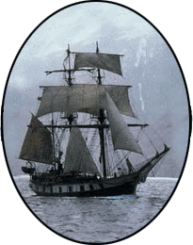

From 1831 to 1836 Darwin sailed the world on the H.M.S. Beagle observing Nature and asking questions never before posed.

CHARLES ROBERT DARWIN
FEBRUARY 12, 1809-APRIL 19, 1882

BICENTENNIAL BIRTHDAY
FEBRUARY 12, 2009

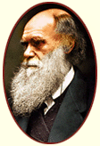

THE UNIVERSITY OF TULSA
SPONSORED BY
DEPARTMENTS OF
BIOLOGICAL SCIENCES &
GEOSCIENCES

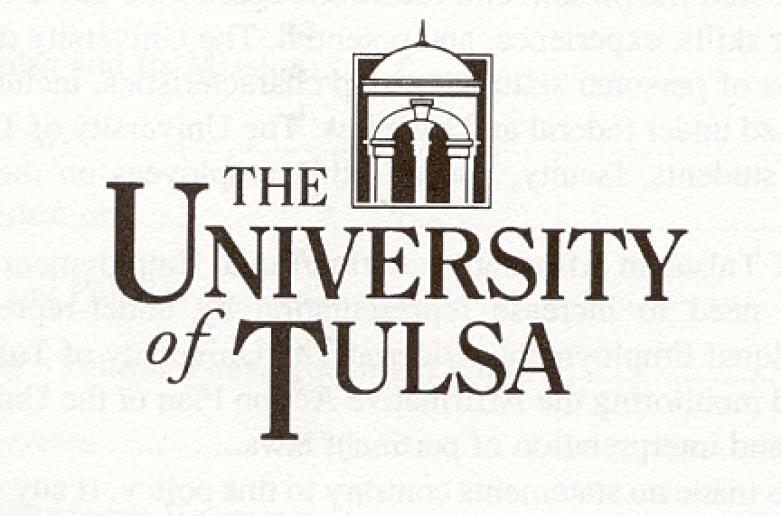

CHARLES ROBERT DARWIN
FEBRUARY 12, 1809-April 19, 1882
FEBRUARY 12, 2009 BICENTENNIAL

The Biological Sciences & Geosciences faculties sponsor this event to inform students and faculty at the University of Tulsa and the larger public community of northeastern Oklahoma about the scientific theory of evolution, its contributions to society, and future scientific developments.

Calendar of Events

February 4: Geosciences Noon Seminar Darwin’s Career, Keplinger Hall M216

February 14: Oklahoma Science Teachers Workshop
Keplinger Hall M1

February 26: 7:00 pm – Public Lecture
Dr. John Mitani, University of Michigan
Primate Behavior

March 11: 7:00 pm – Public Lecture
Dr. Donald Prothero, Occidental College
Evolutionary Paleontologist

For more information call
918-631-2517 or 918-631-3833
For disability accommodations
contact Dr. Jane Corso at
(918) 631-2315

http://www.darwinday.org/home/index.htm
FEBRUARY 26, 7:00 PM
Helmerich Hall

DR. JOHN MITANI

"The Behavior of Wild Chimpanzees"

John Mitani is professor of Anthropology at the University of Michigan. He investigates the behavior of our closest living relatives, the apes. Currently he studies an extremely large community of wild chimpanzees at Ngogo, Kibale National Park, Uganda. During the past 28 years, he has conducted fieldwork on the behavior of all species of apes: gibbons and orangutans in Indonesia, gorillas in Rwanda, bonobos in the Democratic Republic of Congo, and chimpanzees in Uganda and Tanzania. He addresses questions about ape social behavior and communication.

This event is free and open to the public.
Helmrich Hall is 2900 E 5th St.
East of Delaware Ave.

MARCH 11, 7:00 PM
Helmerich Hall

DR. DONALD PROTHERO

“Evolution: what the fossils say and why it matters”

Donald Prothero is Professor of Geology at Occidental College, Los Angeles. He is Phi Beta Kappa and his Ph.D. is from Columbia University. He has authored or edited 25 books and over 200 scientific papers. He has been featured in several TV documentaries. His specialties are mammalian paleontology and magnetic stratigraphy of the Cenozoic. His current research focuses on the dating of the climatic changes that occurred between 30 and 40 million years ago, using the technique of magnetic stratigraphy.

This event is free and open to the public.
Helmrich Hall is 2900 E 5th St.
East of Delaware Ave.

