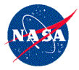
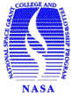
NASA’s Mission to Planet Earth
A Course for Classroom and Pre-Service Teachers
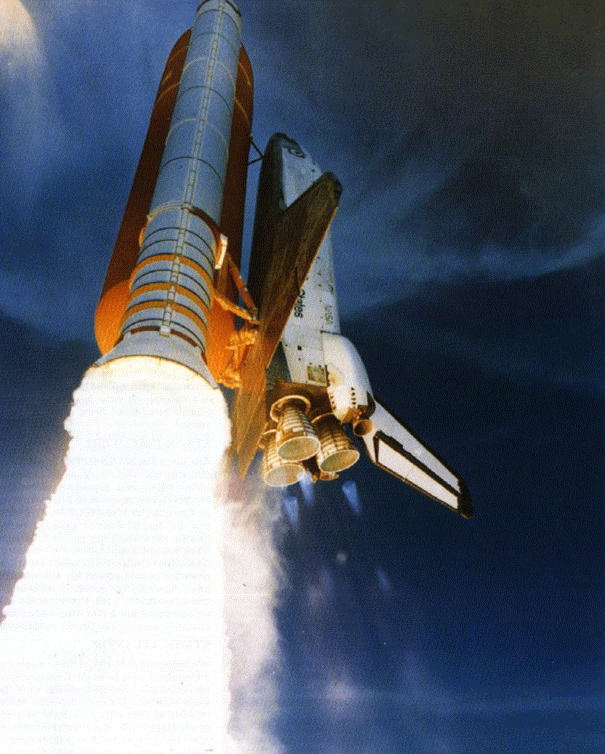
Who: Pre-service and in-service classroom teachers in any
subject area whom teach Grades 2nd – 8th.

What: A 10 day teacher institute

When: June 2nd – 12th, 2010
Where: University of Oklahoma

Why: The Oklahoma NASA Space Grant Consortium
Is sponsoring a summer institute for NASA’s Space Science
Mission Directorate. We call this Mission to Planet
Earth (MTPE). Use the excitement of Aerospace
Education to motivate students with a research-based,
hands-on curriculum across all subject areas. Enhance
your teaching by aligning these motivational activities
with the National Standards and the Oklahoma PASS.
Course Topics

*Basic Principles of Flight

*Classroom Application of Remote Sensing

*Unmanned and Manned Satellites

*Living and Working in Space

*Hands-On Rocketry and Model Rocketry

Special Events

--Experience Interactive Flight
In University-Owned Aircraft

--Field Excursion to the Omniplex
Air and Space Museum/Planetarium

--Field Excursion to Space Imaging
Tracking Station
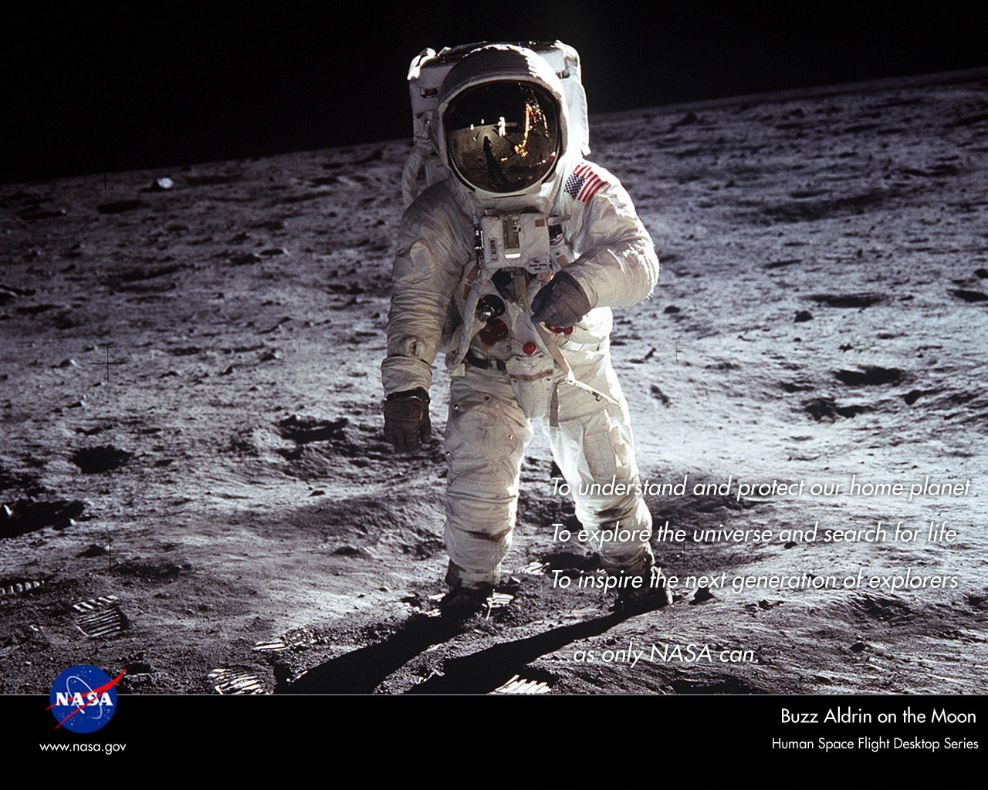
Cost: Selected participants will receive NASA funding that covers the cost of: ten nights lodging, meals for eleven days, morning and afternoon refreshment breaks, handout materials, curriculum notebooks, “mini ground school”, orientation flight in University owned aircraft, flight materials and logbook, and model rocket projects. Also, we will be giving a $250 stipend to all participants!!!

Applications are due in the Oklahoma NASA Space Grant Office at the University of Oklahoma no later than 5PM on December 17th, 2010. All applications will be reviewed on a competitive basis. To receive an application, please contact Stephanie Ponder at 405.325.6559, or via email: StephanieOKSG@ou.edu.

The University of Oklahoma is committed to making its activities accessible to persons with disabilities, language, or other special needs. Accommodations on the basis of disabilities are available by contacting Stephanie Ponder.

